Object Oriented Programmimg
Programs:
1)
#include <iostream>
using namespace std;

int main() {
int a = 5, b = 3;
int sum = a + b;

cout << "Sum is: " << sum;
return 0;
}
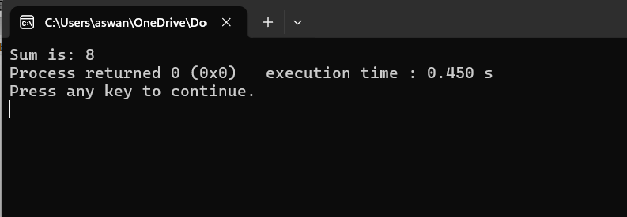
2)
#include <iostream>
using namespace std;

class Student {
private:
string name;
int age;

public:
Student(string n, int a) {
name = n;
age = a;
}

void display() {
cout << "Name: " << name << endl;
cout << "Age: " << age << endl;
}
};

int main() {
Student s1("Riya", 35);
s1.display();

return 0;
}
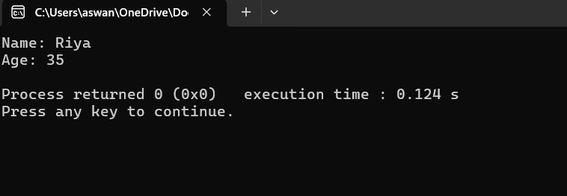
3)
#include <iostream>
using namespace std;

int main() {
int n;

cout << "Enter a number: ";
cin >> n;

for(int i = 1; i <= n; i++) {
cout << i << " ";
}

return 0;
}
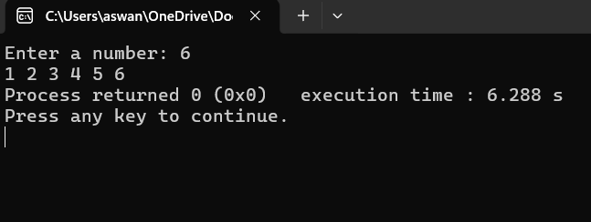4)
#include <iostream>
using namespace std;

int main() {
int a = 5, b = 10, temp;

temp = a;
a = b;
b = temp;

cout << "After swapping: a = " << a << ", b = " << b;
return 0;
}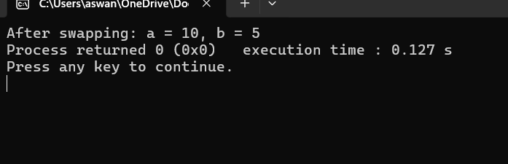5)
#include <iostream>
using namespace std;

int main() {
int n, reverse = 0, remainder;

cout << "Enter a number: ";
cin >> n;

while(n != 0) {
remainder = n % 10;
reverse = reverse * 10 + remainder;
n = n / 10;
}

cout << "Reversed number: " << reverse;
return 0;
}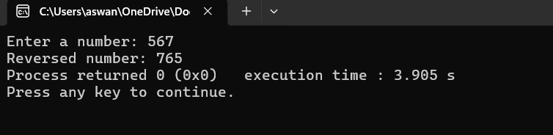6)
#include <iostream>
using namespace std;

int main() {
string str;
int vowels = 0, consonants = 0;

cout << "Enter a string: ";
getline(cin, str);

for(int i = 0; i < str.length(); i++) {
char ch = tolower(str[i]);

if(isalpha(ch)) {
if(ch == 'a' || ch == 'e' || ch == 'i' || ch == 'o' || ch == 'u')
vowels++;
else
consonants++;
}
}

cout << "Vowels: " << vowels << endl;
cout << "Consonants: " << consonants << endl;

return 0;
}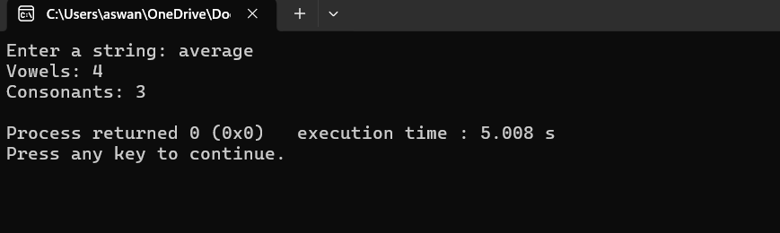7)
#include <iostream>
using namespace std;

class Employee {
public:
int id;
string name;
float salary;

void input() {
cout << "Enter ID: ";
cin >> id;
cin.ignore();

cout << "Enter Name: ";
getline(cin, name);

cout << "Enter Salary: ";
cin >> salary;
}

void display() {
cout << "\nID: " << id << endl;
cout << "Name: " << name << endl;
cout << "Salary: " << salary << endl;
}
};

int main() {
Employee emp[3];

cout << "Enter details of 3 employees:\n";

for(int i = 0; i < 3; i++) {
cout << "\nEmployee " << i + 1 << ":\n";
emp[i].input();
}

cout << "\n--- Employee Details ---\n";

for(int i = 0; i < 3; i++) {
cout << "\nEmployee " << i + 1 << ":";
emp[i].display();
}

return 0;}
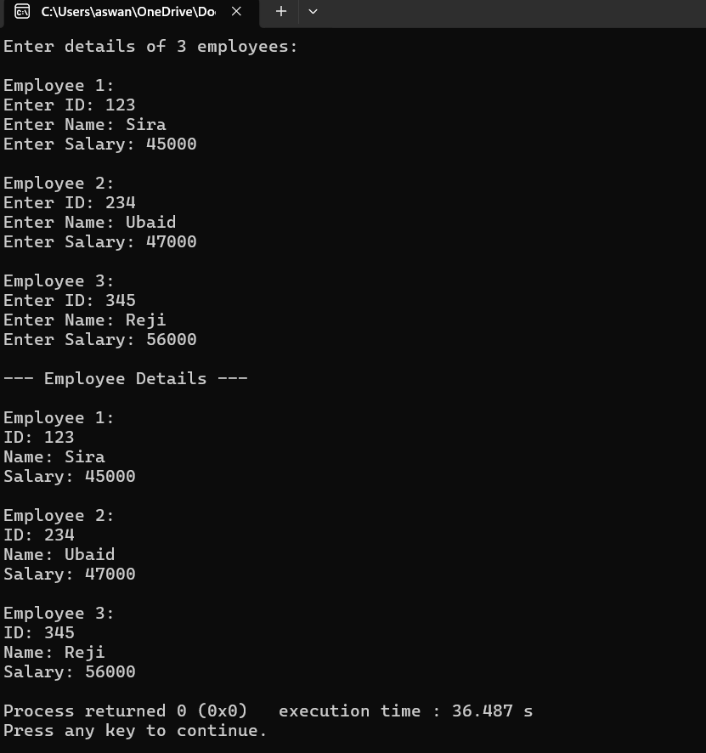

8)
#include <iostream>
using namespace std;

class Employee {
public:
int id;
string name;
float salary;

void input() {
cout << "Enter ID: ";
cin >> id;
cin.ignore();

cout << "Enter Name: ";
getline(cin, name);

cout << "Enter Salary: ";
cin >> salary;
}

void display() {
cout << "ID: " << id << ", Name: " << name << ", Salary: " << salary << endl;
}
};

int main() {
Employee emp[100];
int count = 0;
int choice;

do {
cout << "\n--- MENU ---\n";
cout << "1. Add Employee\n";
cout << "2. Display All\n";
cout << "3. Search by ID\n";
cout << "4. Delete Employee\n";
cout << "5. Exit\n";
cout << "Enter choice: ";
cin >> choice;

switch(choice) {
case 1: {
if(count < 100) {
cout << "\nEnter Employee Details:\n";
emp[count].input();
count++;
} else {
cout << "Employee list is full!\n";
}
break;
}

case 2: {
if(count == 0) {
cout << "No employees to display.\n";
} else {
cout << "\nEmployee List:\n";
for(int i = 0; i < count; i++) {
emp[i].display();
}
}
break;
}

case 3: {
int searchId, found = 0;
cout << "Enter ID to search: ";
cin >> searchId;

for(int i = 0; i < count; i++) {
if(emp[i].id == searchId) {
cout << "Employee Found:\n";
emp[i].display();
found = 1;
break;
}
}

if(!found) {
cout << "Employee not found.\n";
}
break;
}

case 4: {
int deleteId, found = 0;
cout << "Enter ID to delete: ";
cin >> deleteId;

for(int i = 0; i < count; i++) {
if(emp[i].id == deleteId) {
for(int j = i; j < count - 1; j++) {
emp[j] = emp[j + 1];
}
count--;
cout << "Employee deleted.\n";
found = 1;
break;
}
}

if(!found) {
cout << "Employee not found.\n";
}
break;
}

case 5:
cout << "Exiting program...\n";
break;

default:
cout << "Invalid choice!\n";
}

} while(choice != 5);

return 0;}
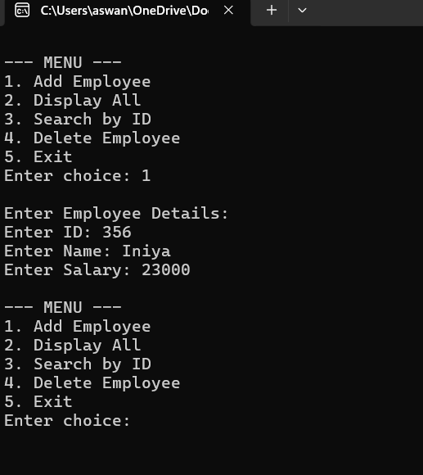
9)
#include <iostream>
using namespace std;

struct Student {
int id;
string name;
float marks;
};

int main() {
int n;
cout << "Enter number of students: ";
cin >> n;

Student s[n];

for(int i = 0; i < n; i++) {
cout << "\nStudent " << i + 1 << ":\n";
cout << "Enter ID: ";
cin >> s[i].id;
cin.ignore();

cout << "Enter Name: ";
getline(cin, s[i].name);

cout << "Enter Marks: ";
cin >> s[i].marks;
}

int maxIndex = 0;
for(int i = 1; i < n; i++) {
if(s[i].marks > s[maxIndex].marks) {
maxIndex = i;
}
}

cout << "\nStudent with Highest Marks:\n";
cout << "ID: " << s[maxIndex].id << endl;
cout << "Name: " << s[maxIndex].name << endl;
cout << "Marks: " << s[maxIndex].marks << endl;

return 0;
}
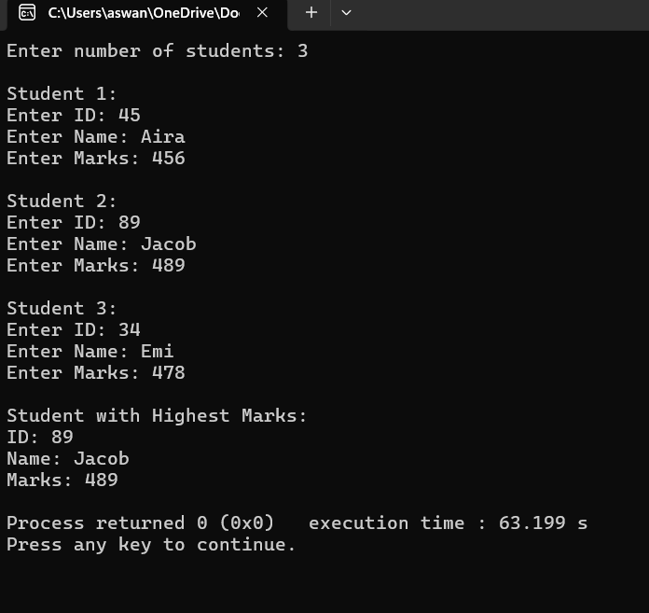
10)
#include <iostream>
using namespace std;

int main() {
int n;
cout << "Enter a number: ";
cin >> n;

for(int i = 1; i <= 10; i++) {
cout << n << " x " << i << " = " << n * i << endl;
}

return 0;
}
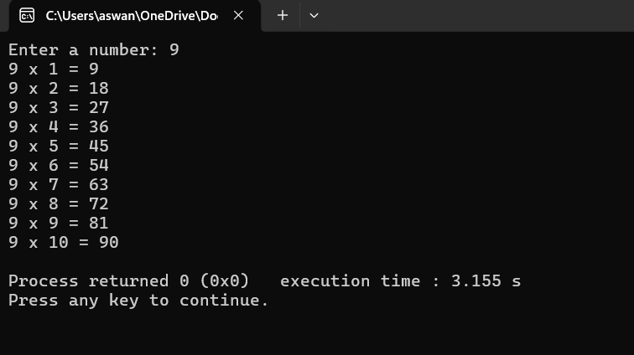11)
#include <iostream>
using namespace std;

void deposit(int *balance, int amount) {
*balance += amount;
}

int main() {
int balance = 1000;
deposit(&balance, 500);
cout << "Updated Balance: " << balance;
}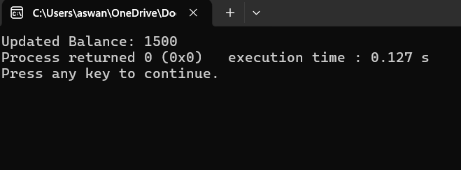12)
#include <iostream>
using namespace std;

class Employee {
int salary = 30000;
friend class HR;
};

class HR {
public:
void display(Employee e) {
cout << "Salary: " << e.salary;
}
};

int main() {
Employee e;
HR h;
h.display(e);
}
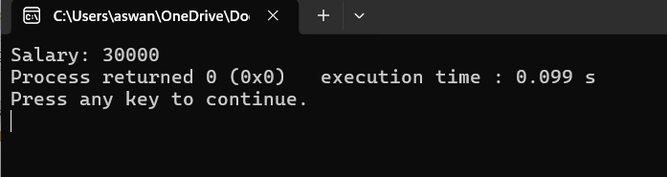13)
#include <iostream>
using namespace std;

template <class T>
class Box {
T value;
public:
Box(T v) { value = v; }
void show() { cout << value; }
};

int main() {
Box<int> b1(10);
Box<string> b2("Hello");

b1.show();
cout << endl;
b2.show();
}
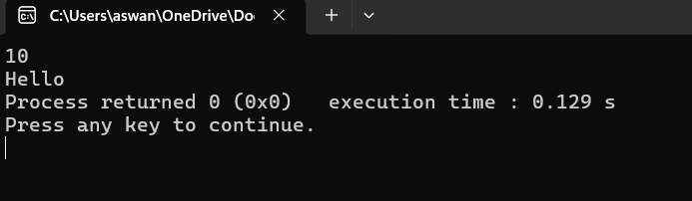14)
#include <iostream>
using namespace std;

class Person {
protected:
string name;
int age;
public:
void getPerson() {
cout << "Enter Name: ";
cin >> name;
cout << "Enter Age: ";
cin >> age;
}
};

class Student : public Person {
int marks;
public:
void getStudent() {
getPerson();
cout << "Enter Marks: ";
cin >> marks;
}

void display() {
cout << "\n--- Student Details ---\n";
cout << "Name: " << name << endl;
cout << "Age: " << age << endl;
cout << "Marks: " << marks << endl;
}
};

int main() {
Student s;
s.getStudent();
s.display();
}
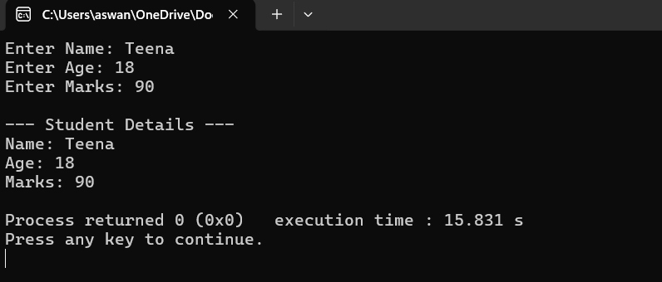15)
#include <iostream>
using namespace std;

class Salary {
protected:
float basic;
public:
void getSalary() {
cout << "Enter Basic Salary: ";
cin >> basic;
}
};

class Bonus {
protected:
float bonus;
public:
void getBonus() {
cout << "Enter Bonus: ";
cin >> bonus;
}
};

class Employee : public Salary, public Bonus {
string name;
public:
void getData() {
cout << "Enter Employee Name: ";
cin >> name;
getSalary();
getBonus();
}

void calculate() {
float total = basic + bonus;
cout << "\nEmployee: " << name << endl;
cout << "Total Salary: " << total << endl;
}
};

int main() {
Employee e;
e.getData();
e.calculate();
}
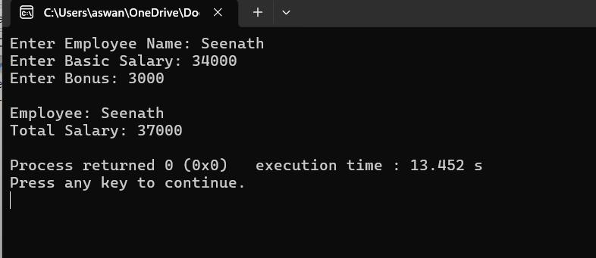
16)
#include <iostream>
using namespace std;

class Vehicle {
public:
string brand;
};

class Car : virtual public Vehicle {
public:
void getCar() {
cout << "Enter Car Brand: ";
cin >> brand;
}
};

class Bike : virtual public Vehicle {
public:
void getBike() {
cout << "Enter Bike Brand: ";
cin >> brand;
}
};

class Showroom : public Car, public Bike {
public:
void display() {
cout << "\nVehicle Brand: " << brand << endl;
}
};

int main() {
Showroom s;

int choice;
cout << "1. Car\n2. Bike\nEnter choice: ";
cin >> choice;

if(choice == 1)
s.getCar();
else
s.getBike();

s.display();
}
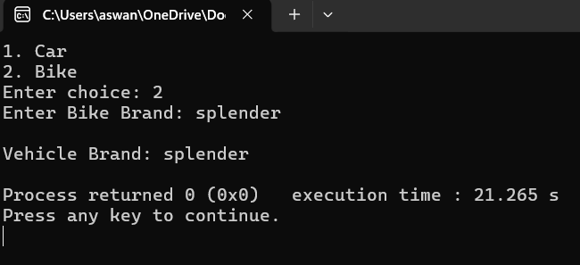
17)
#include <iostream>
using namespace std;

int main() {
int balance = 1000, withdraw;
cin >> withdraw;

try {
if(withdraw > balance)
throw "Insufficient Balance!";
cout << "Withdrawn Successfully";
}
catch(const char* msg) {
cout << msg;
}
}
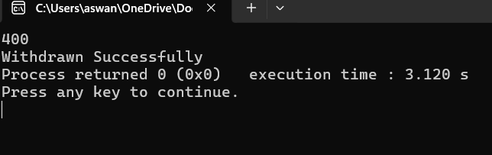
18)
#include <iostream>
#include <vector>
#include <algorithm>
using namespace std;

int main() {
vector<int> v = {1,2,2,3,3,4};

sort(v.begin(), v.end());
v.erase(unique(v.begin(), v.end()), v.end());

for(int x : v)
cout << x << " ";
}
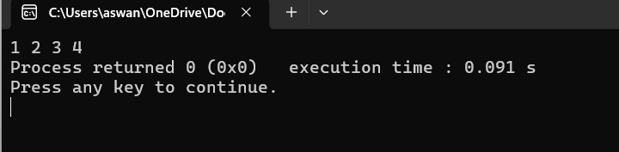
19)
#include <iostream>
#include <fstream>
using namespace std;

class Student {
int id;
string name;
float marks;
public:
void input() {
cout << "Enter ID, Name, Marks: ";
cin >> id >> name >> marks;
}

void writeToFile() {
ofstream file("students.txt", ios::app);
file << id << " " << name << " " << marks << endl;
file.close();
}

void display() {
ifstream file("students.txt");
int i; string n; float m;
cout << "\n--- Records ---\n";
while(file >> i >> n >> m) {
cout << i << " " << n << " " << m << endl;
}
file.close();
}
};

int main() {
Student s;
int choice;

do {
cout << "\n1.Add 2.View 3.Exit: ";
cin >> choice;

if(choice == 1) {
s.input();
s.writeToFile();
}
else if(choice == 2) {
s.display();
}

} while(choice != 3);
}
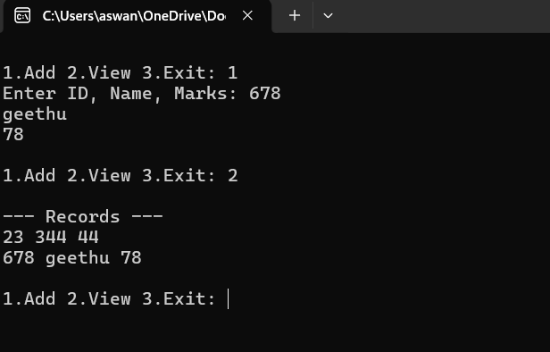
20)
#include <iostream>
using namespace std;

class Account {
protected:
float balance;
public:
void getBalance() {
cout << "Enter Balance: ";
cin >> balance;
}
};

class Transaction : public Account {
public:
void withdraw() {
float amt;
cout << "Enter amount: ";
cin >> amt;

try {
if(amt > balance)
throw "Insufficient Balance!";
balance -= amt;
cout << "Remaining: " << balance;
}
catch(const char* msg) {
cout << msg;
}
}
};

int main() {
Transaction t;
t.getBalance();
t.withdraw();
}
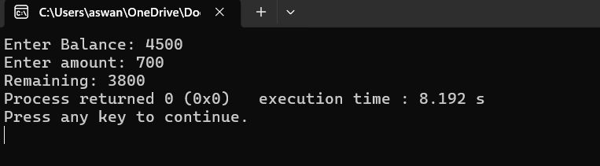
21)
#include <iostream>
#include <queue>
using namespace std;

int main() {
queue<string> q;
int choice;
string name;

do {
cout << "\n1.Add Person 2.Serve 3.Exit: ";
cin >> choice;

if(choice == 1) {
cout << "Enter name: ";
cin >> name;
q.push(name);
}
else if(choice == 2) {
if(!q.empty()) {
cout << q.front() << " served\n";
q.pop();
} else {
cout << "Queue Empty\n";
}
}

} while(choice != 3);
}
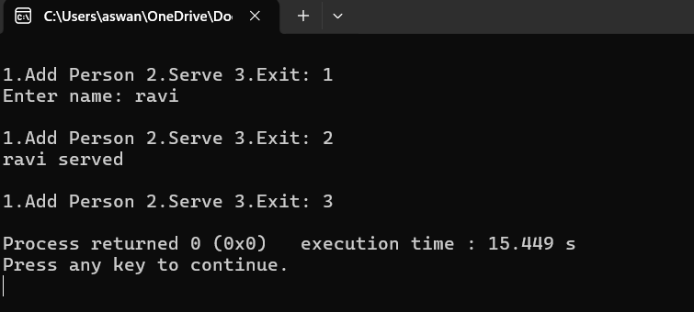
22)
#include <iostream>
#include <vector>
#include <algorithm>
using namespace std;

int main() {
vector<int> v;
int n, x;

cout << "Enter size: ";
cin >> n;

cout << "Enter elements:\n";
for(int i=0;i<n;i++) {
cin >> x;
v.push_back(x);
}

sort(v.begin(), v.end());

cout << "Sorted: ";
for(int i : v) cout << i << " ";

cout << "\nMax: " << v.back();
cout << "\nMin: " << v.front();
}
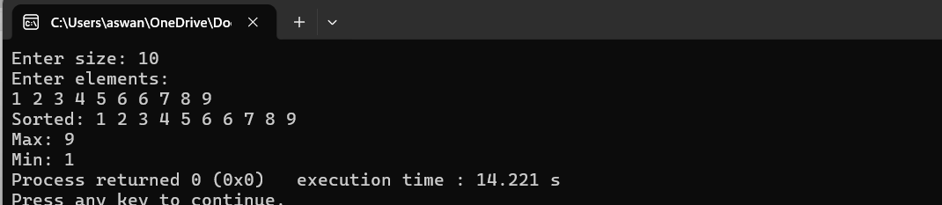
23)
#include <iostream>
#include <exception>
using namespace std;

class InsufficientBalance : public exception {
public:
const char* what() const noexcept {
return "Error: Insufficient Balance!";
}
};

int main() {
double balance, withdraw;

cout << "Enter Balance: ";
cin >> balance;

cout << "Enter Amount to Withdraw: ";
cin >> withdraw;

try {
if(withdraw > balance) {
throw InsufficientBalance();
}
balance -= withdraw;
cout << "Transaction Successful\nRemaining Balance: " << balance;
}
catch(const exception& e) {
cout << e.what(); // similar to e.message
}

return 0;
}
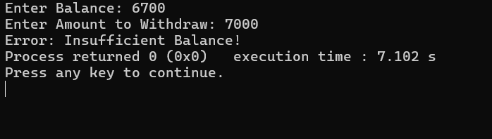
24)
#include <iostream>
using namespace std;

class Payment {
public:
virtual void pay() = 0; // pure virtual function
};

class UPI : public Payment {
float amount;
public:
void input() {
cout << "Enter UPI Amount: ";
cin >> amount;
}
void pay() {
cout << "Paid " << amount << " using UPI";
}
};

class Card : public Payment {
float amount;
public:
void input() {
cout << "Enter Card Amount: ";
cin >> amount;
}
void pay() {
cout << "Paid " << amount << " using Card";
}
};

int main() {
int choice;

cout << "1. UPI\n2. Card\nEnter choice: ";
cin >> choice;

if(choice == 1) {
UPI u;
u.input();
u.pay();
} else {
Card c;
c.input();
c.pay();
}
}
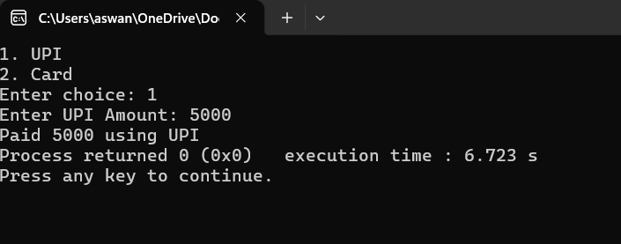
25)
#include <iostream>
#include <fstream>
#include <exception>
using namespace std;

// Custom exception
class FileError : public exception {
public:
const char* what() const noexcept {
return "Error: Unable to open file!";
}
};

class Employee {
int id;
string name;
float salary;

public:
void input() {
cout << "Enter ID, Name, Salary: ";
cin >> id >> name >> salary;
}

void writeToFile() {
ofstream file("employee.txt", ios::app);

if(!file)
throw FileError();

file << id << " " << name << " " << salary << endl;
file.close();

cout << "Record Saved Successfully\n";
}

void displayFile() {
ifstream file("employee.txt");

if(!file)
throw FileError();

cout << "\n--- Employee Records ---\n";

while(file >> id >> name >> salary) {
cout << id << " " << name << " " << salary << endl;
}

file.close();
}
};

int main() {
Employee e;
int choice;

do {
cout << "\n1.Add Record\n2.View Records\n3.Exit\nEnter choice: ";
cin >> choice;

try {
if(choice == 1) {
e.input();
e.writeToFile();
}
else if(choice == 2) {
e.displayFile();
}
}
catch(const exception& ex) {
cout << ex.what(); // error message
}

} while(choice != 3);

return 0;
}
